**MEDICAL INVENTORY MANAGEMENT**

**College Name: Akshaya College of Arts and Science**

**College Code: brubw**

**TEAM ID: NM2025TMID24864**

# TEAM MEMBERS: 4

**Team LeaderName: Y.samuel abishai pranay**

**Email: 23cssamuelabishai@acascbe.edu.in**

**Team Member: vijayaragavan.s**

**Email: 23csvijayragavan@acascbe.edu.in**

**Team Member: SARULATHA K**

**Email: 23cssarulatha@acascbe.edu.in Team Member: TAMIL D**

**Email: 23cstamil@acascbe.edu.in**

# 1.INTRODUCTION

## **1.1 Project Overview**

The Medical Inventory Management is a system to manage medical products and suppliers.It records purchase orders and order items in one place.

The system tracks stock using inventory transactions.It helps calculate total costs automatically.Overall, it makes medical stock handling easy and accurate.

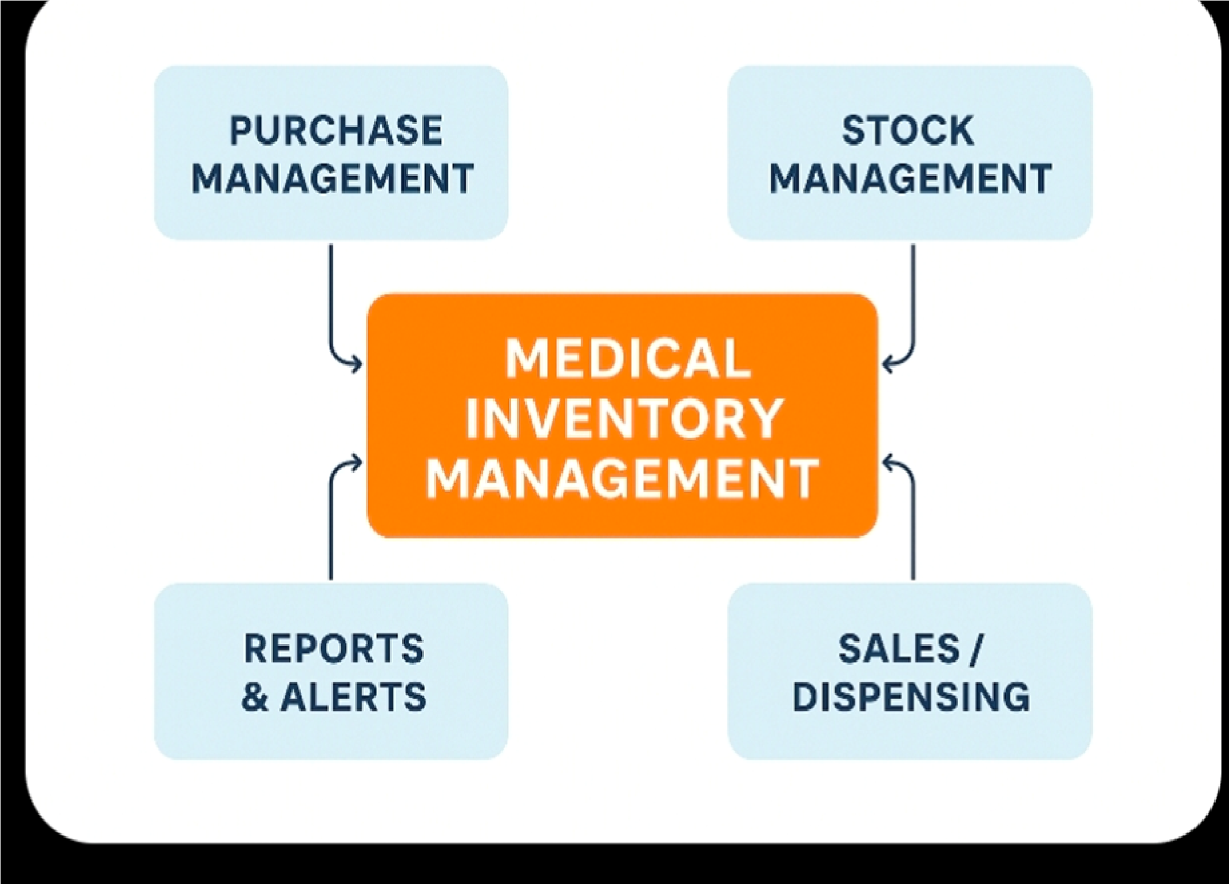

## **1.2 Purpose**

The purpose of the Medical Inventory Management project is to maintain accurate records of medical products, suppliers, and stock levels, ensuring smooth purchase order handling and efficient inventory tracking

# DEVELOPMENT PHASE

**Creating Developer Account:**

By using this URL **- https://www.salesforce.com/form/developer-signup/?d=pb**

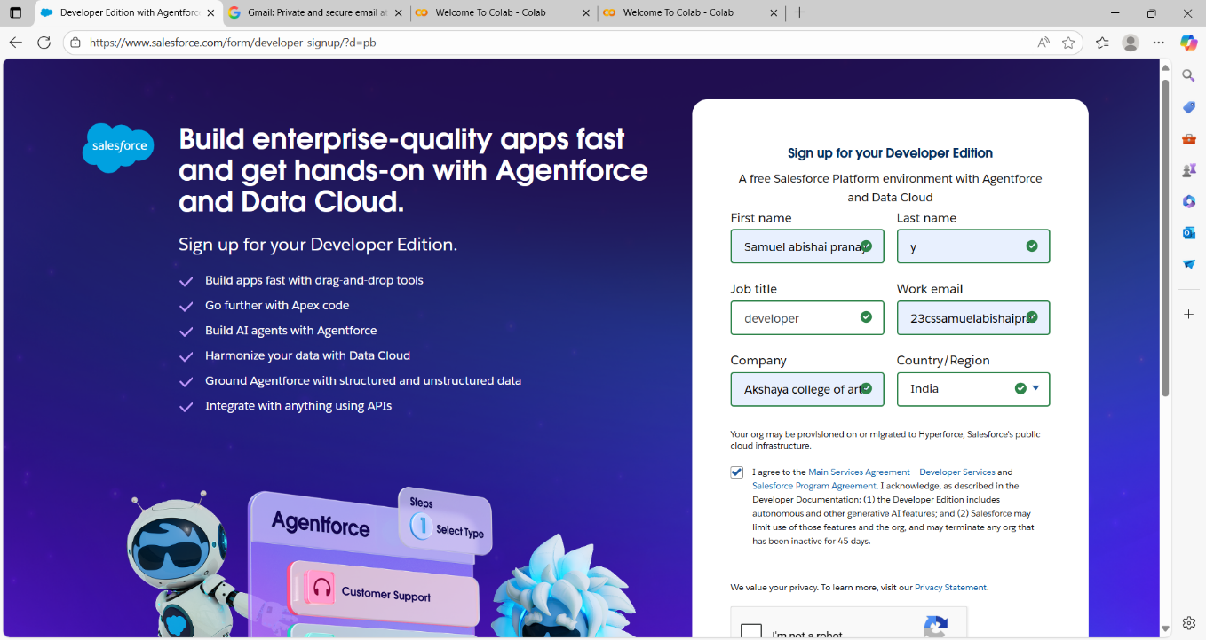

* Created objects: Product, Purchase Order, Order Item, Inventory Transaction and Suppliers

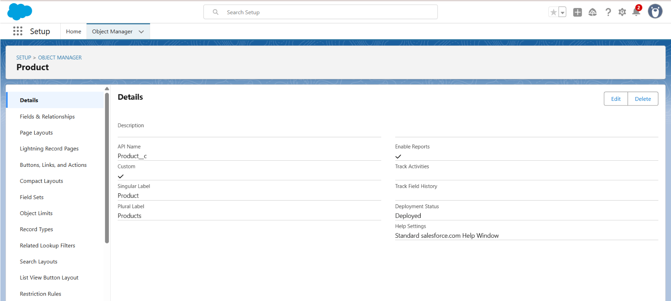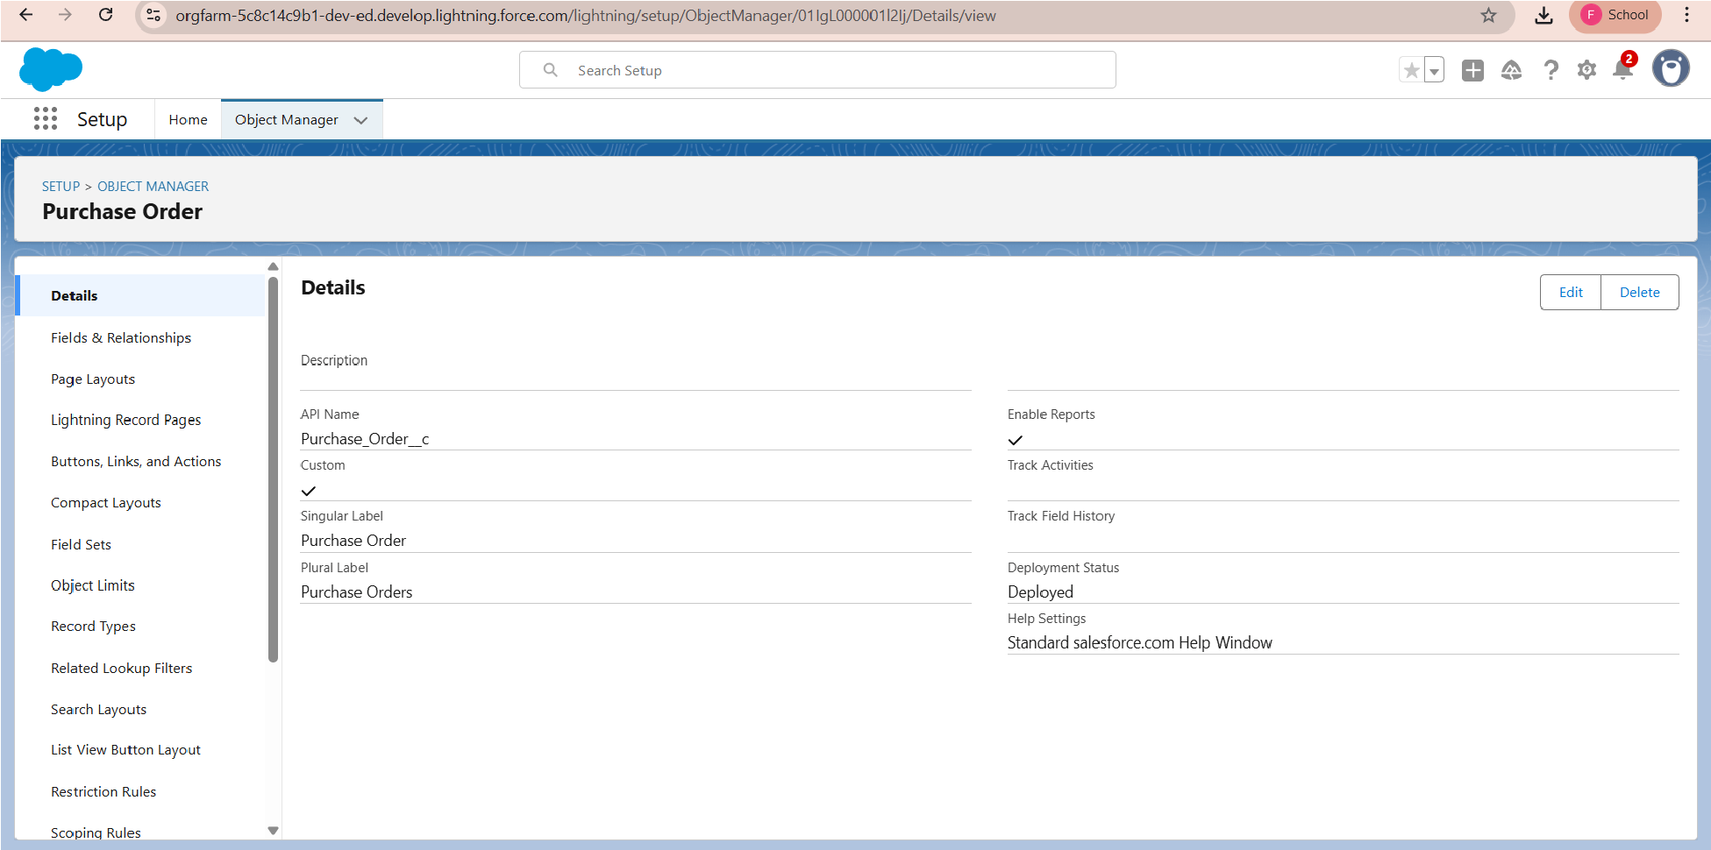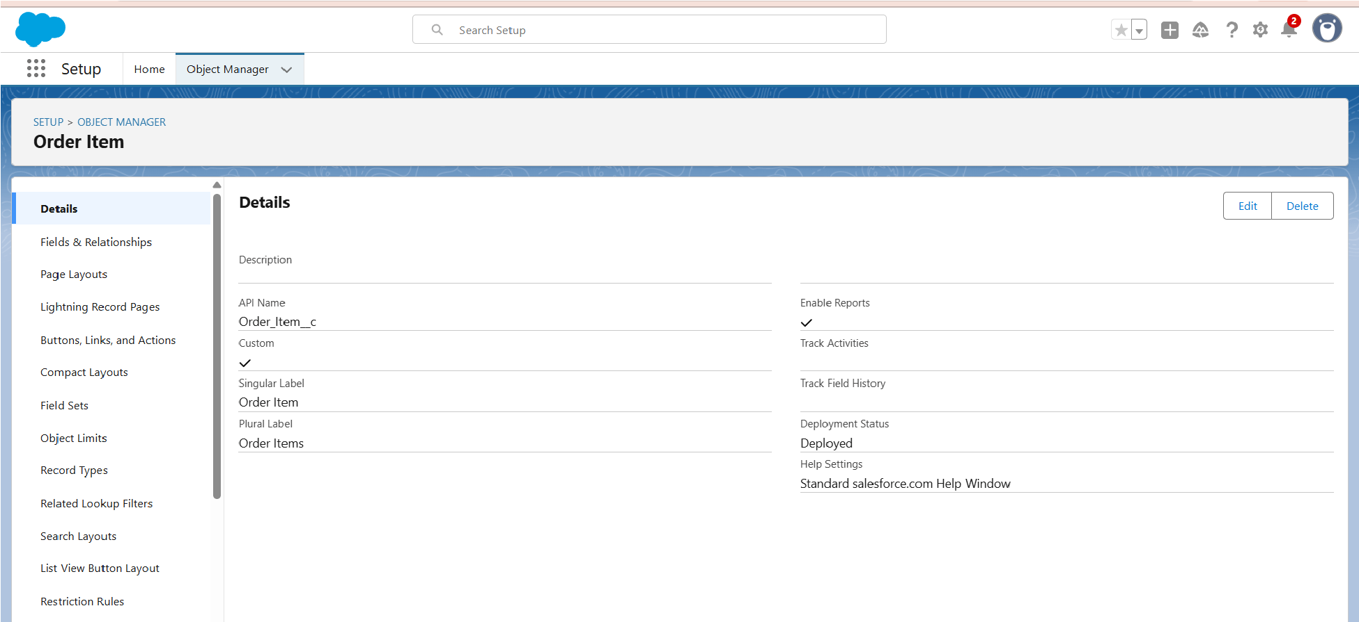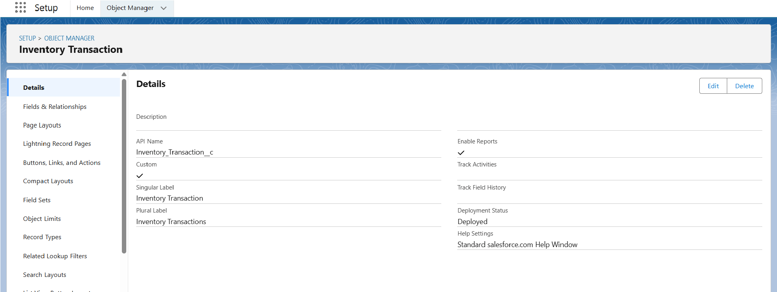

* Configured fields and relationships

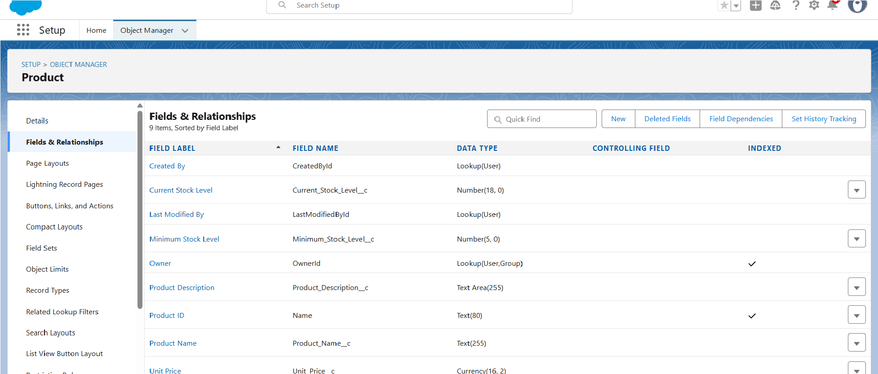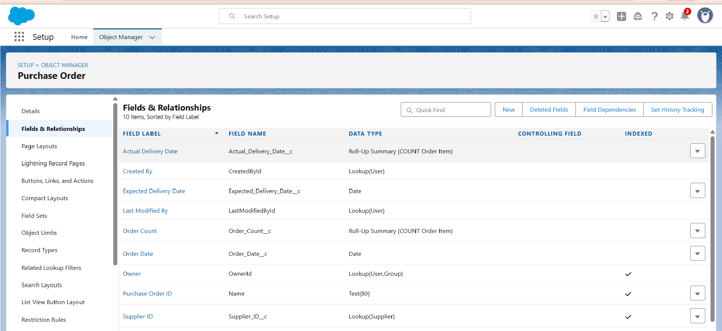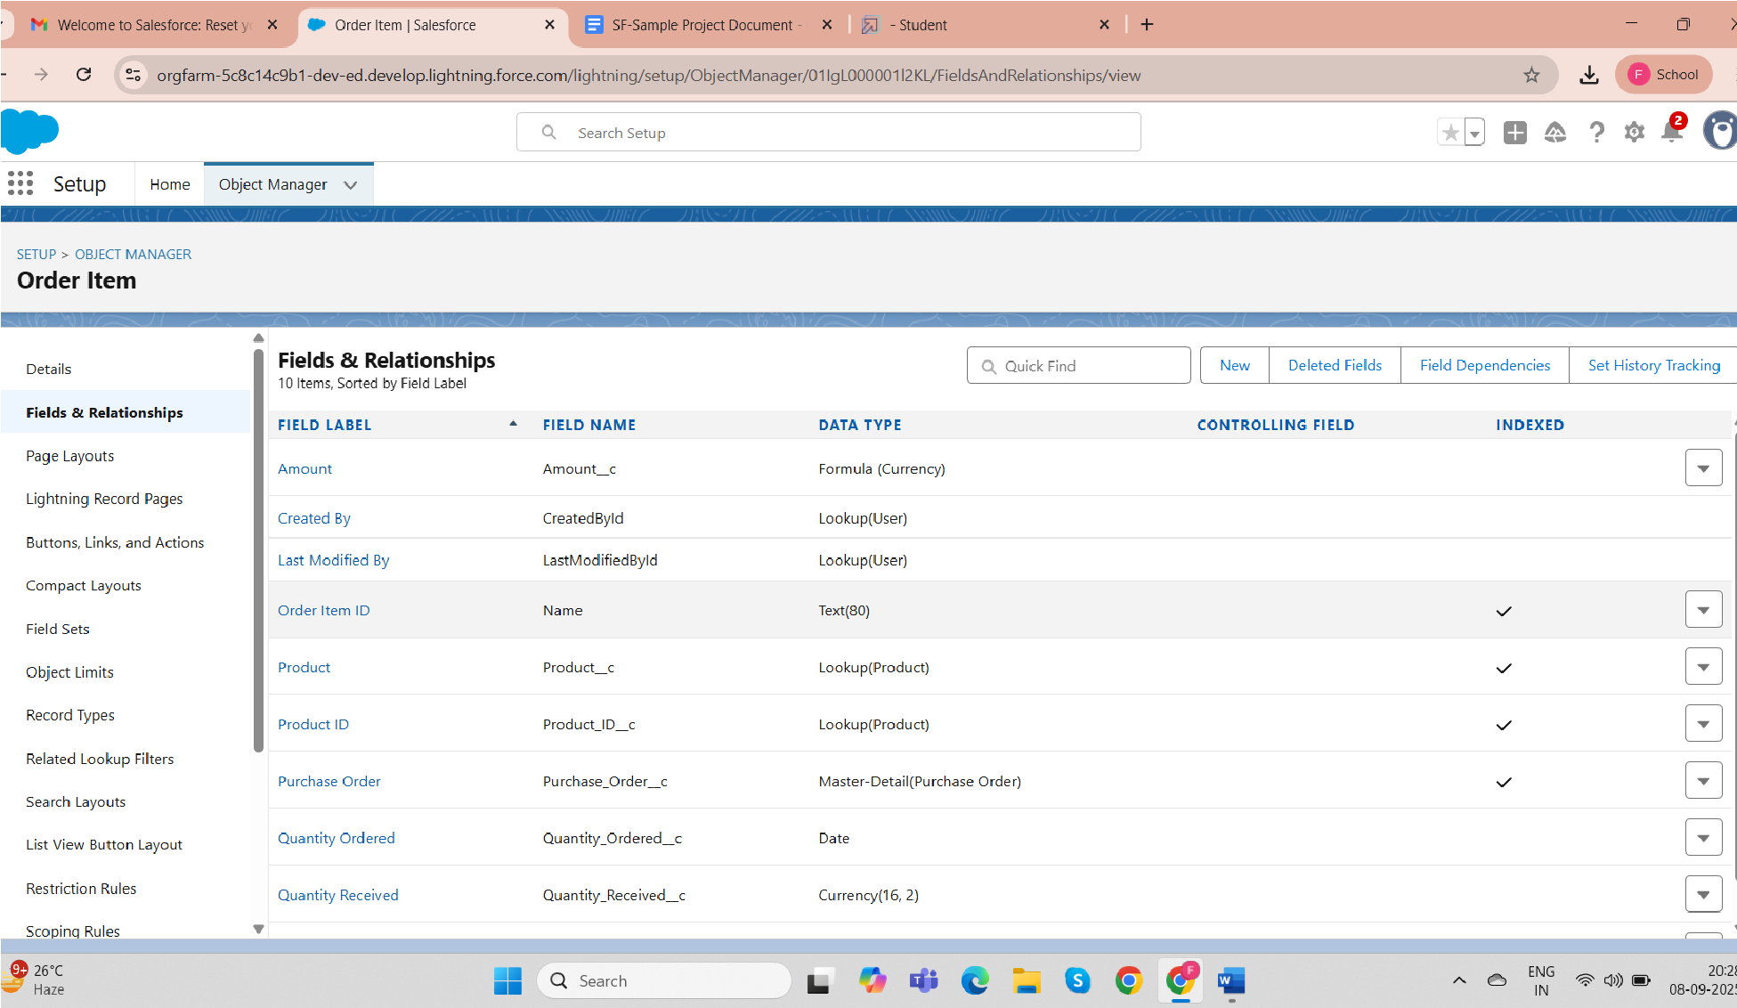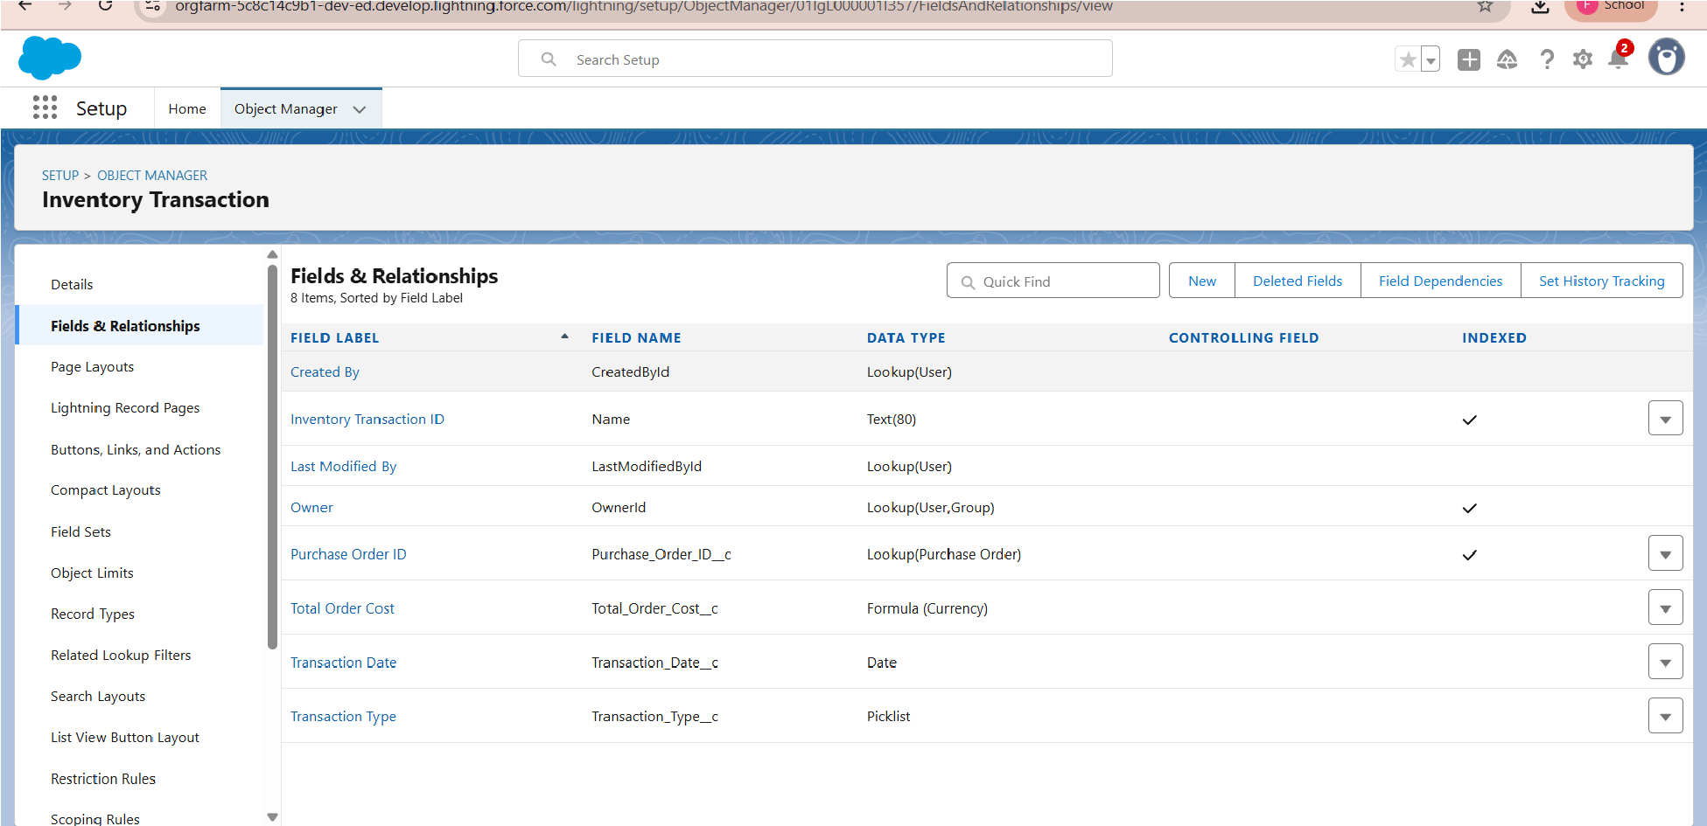

* Create a required fields in the above following objects like Product,Purchase Order,Order item,Inventory Transaction,Supplier

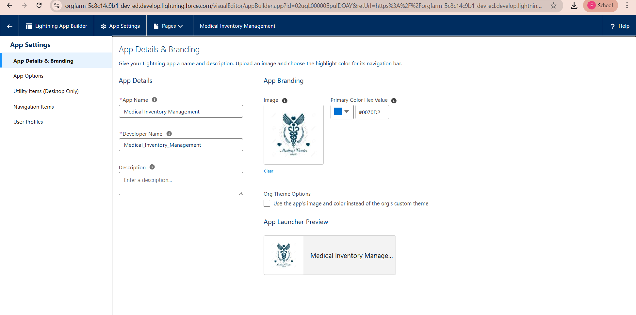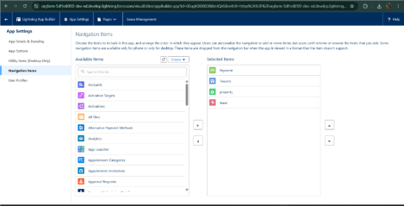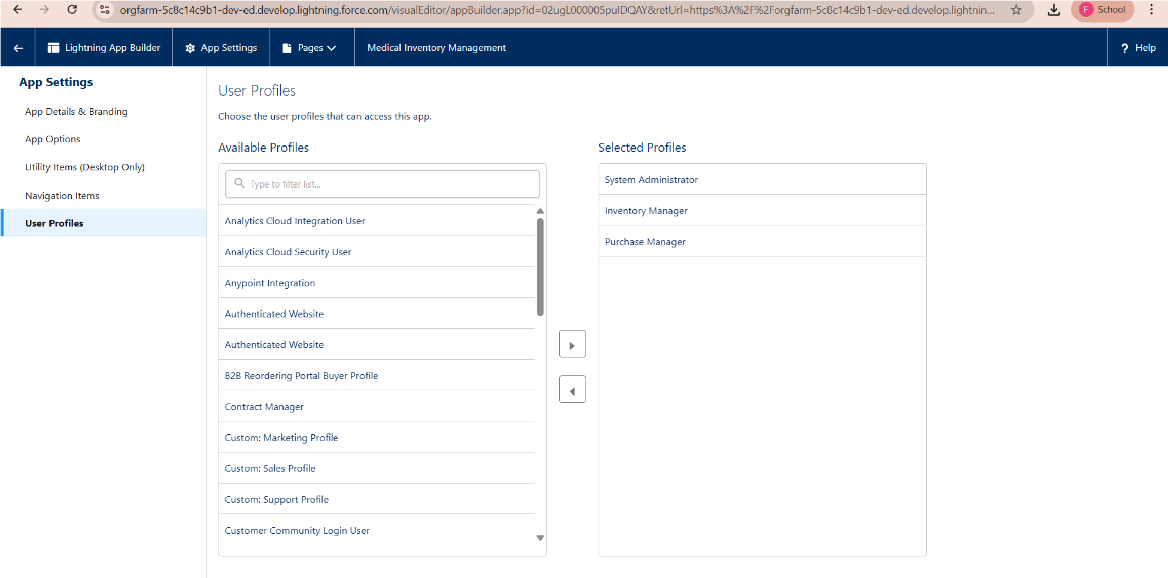

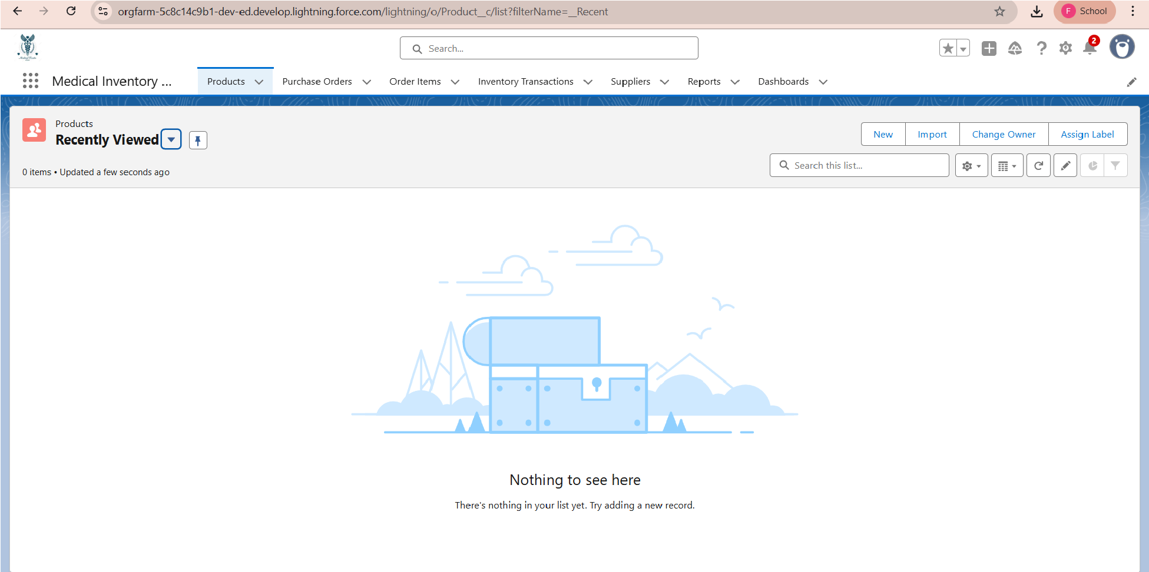

* Edit the page layouts in the created custom objects like product,purchase order,order item,inventory transaction,supplier

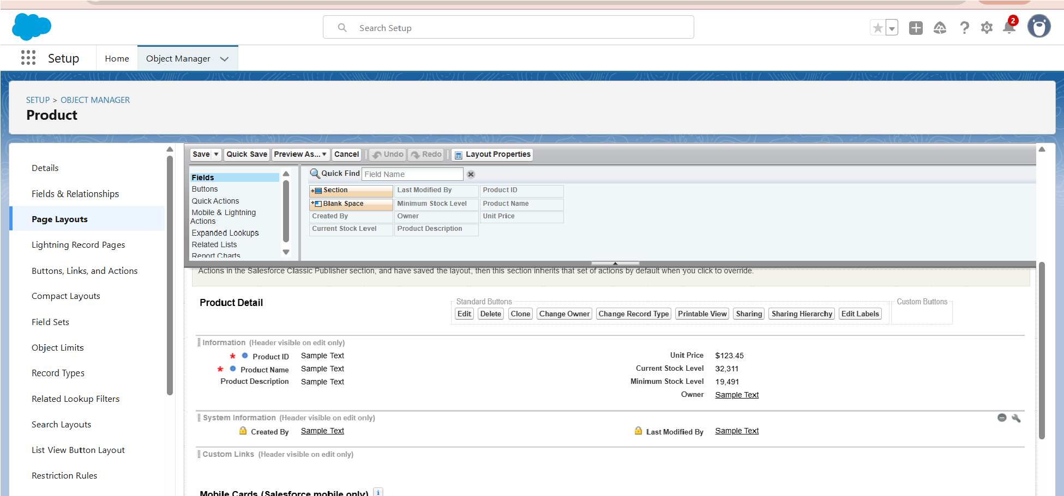

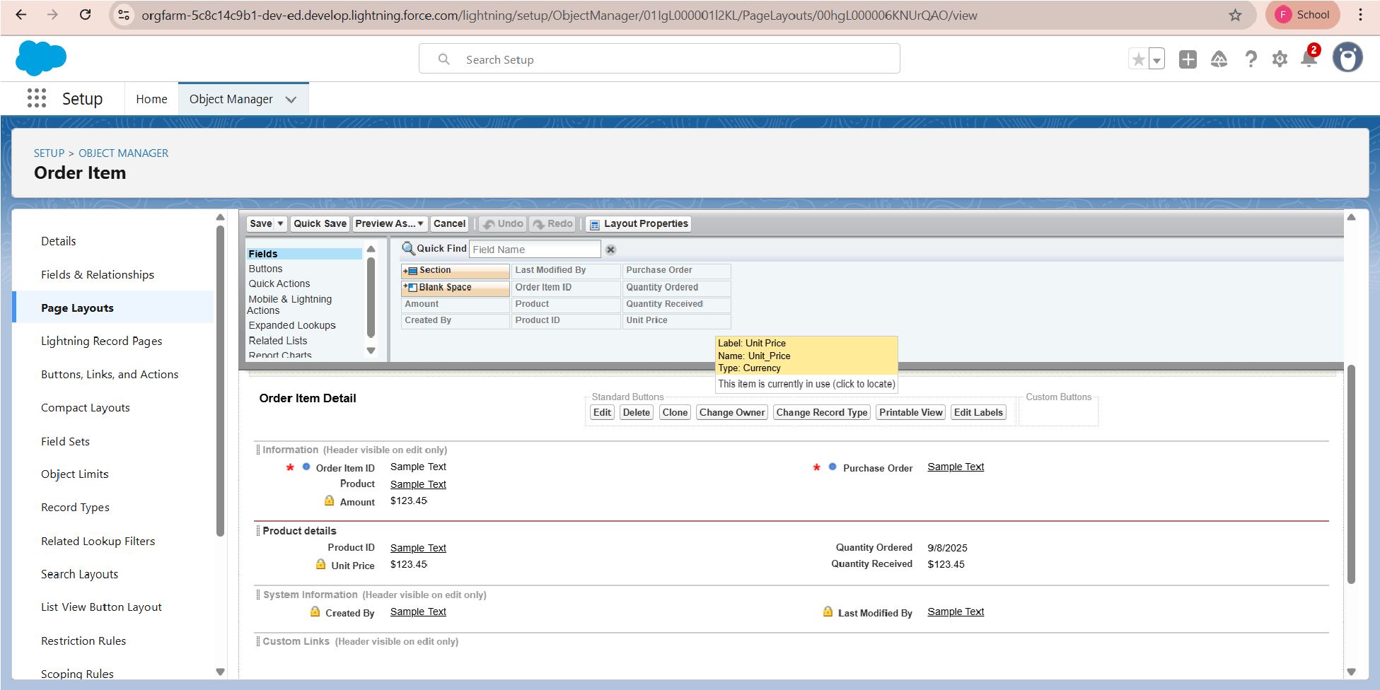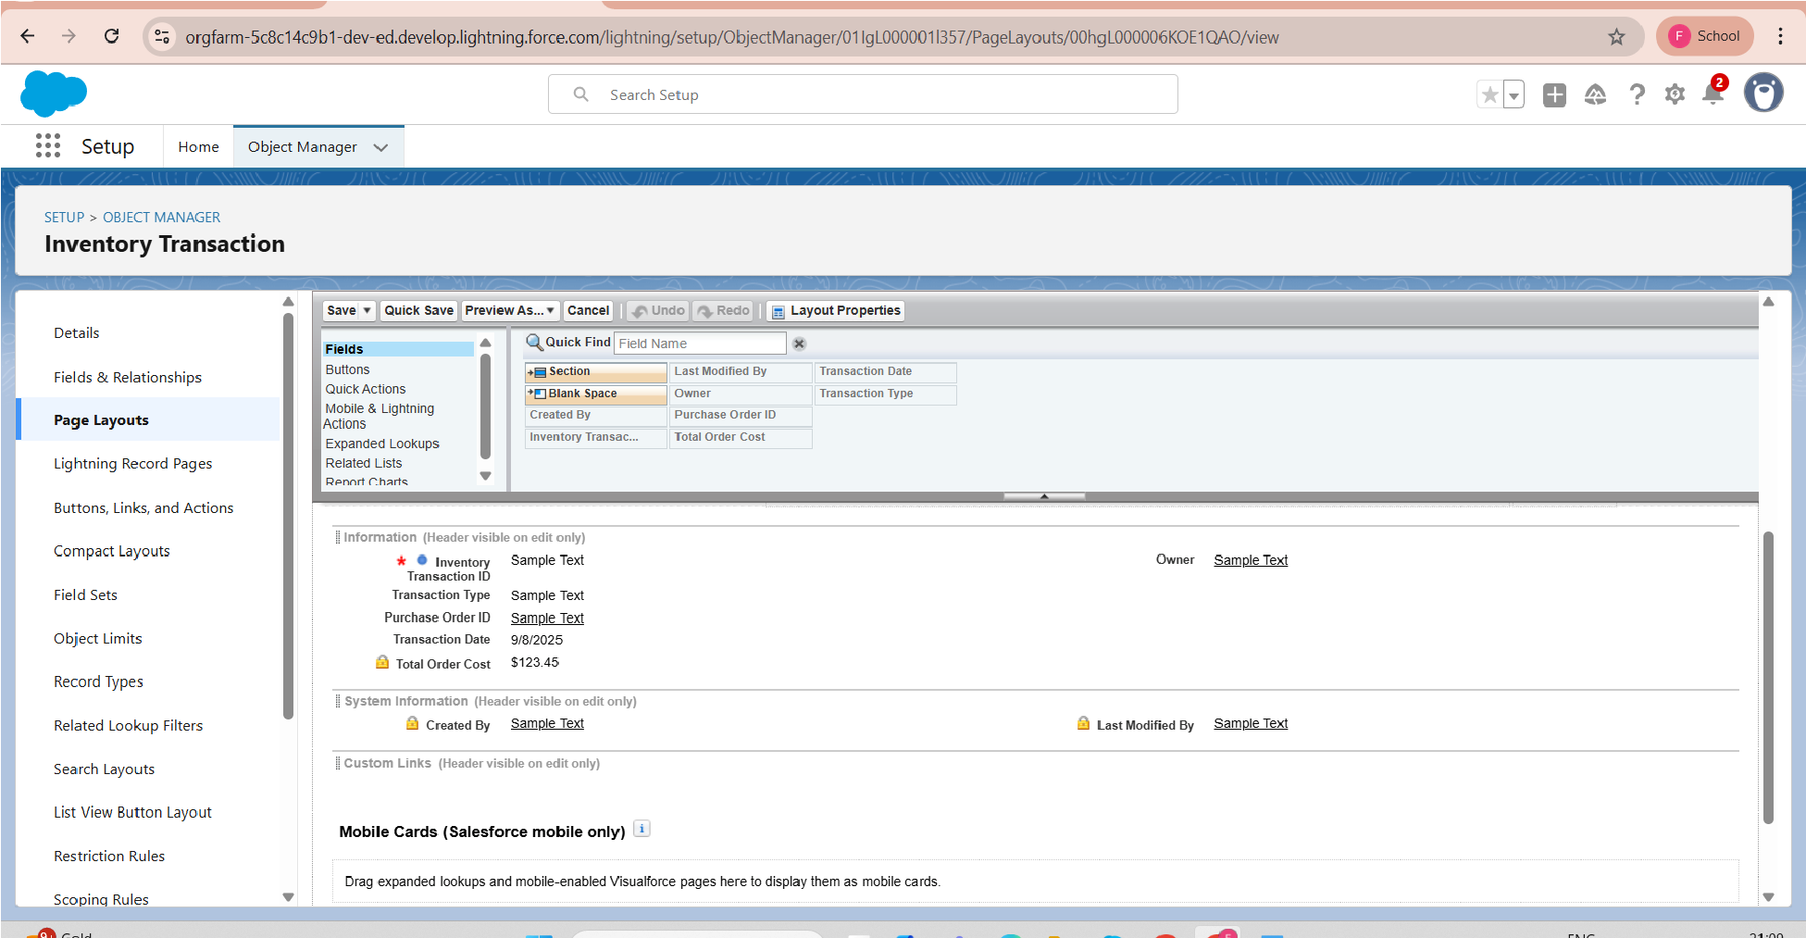

* Also edit the page layouts in purchase order and supplier, then create a compact layout to a product and purchase order object

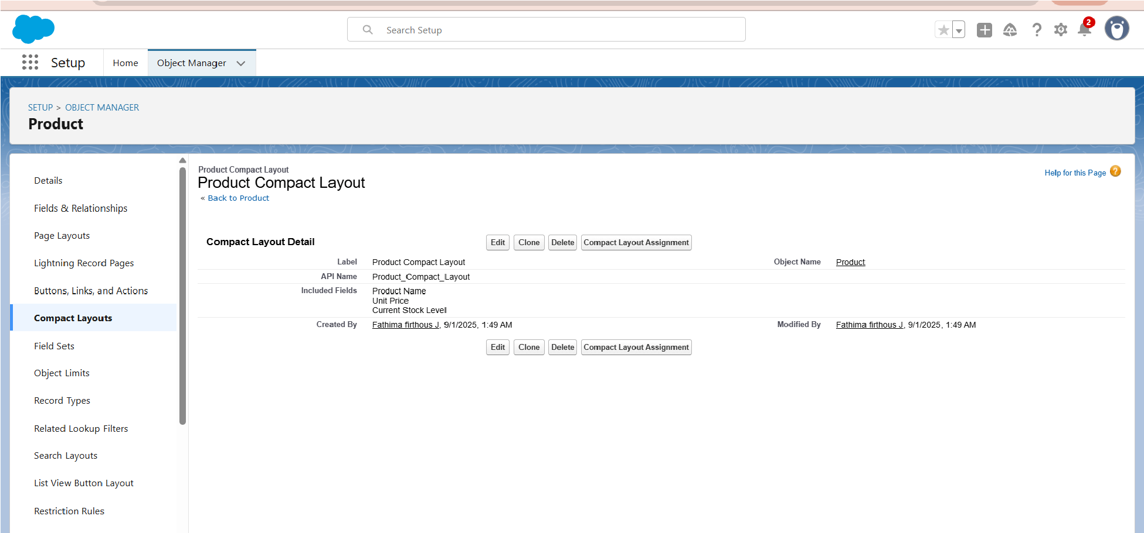

* Likewise create a compact layout also in a purchase order object in name of purchase order compact layout,then create a validation rule for the purchase order object

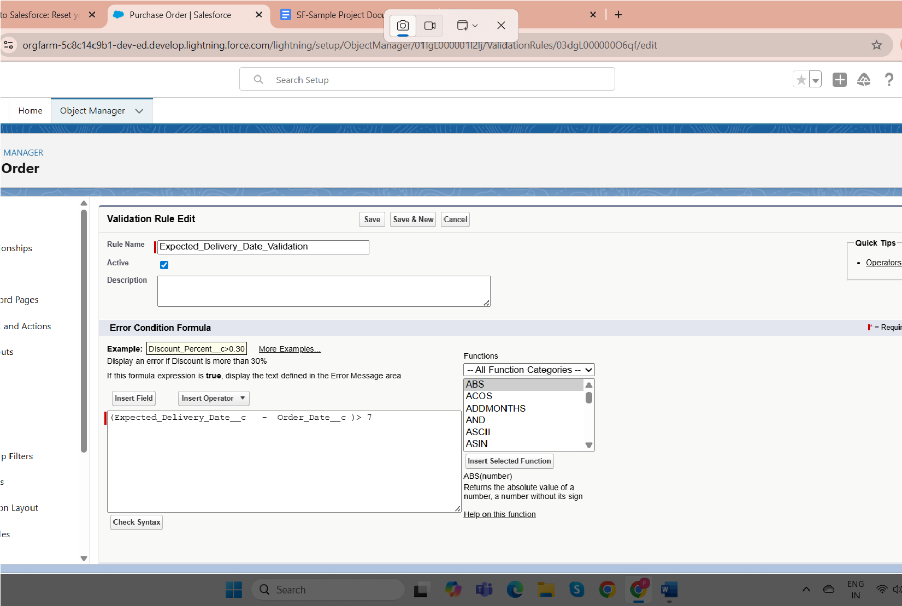

* To create a Inventory manager profile and purchase inventory profile in profiles

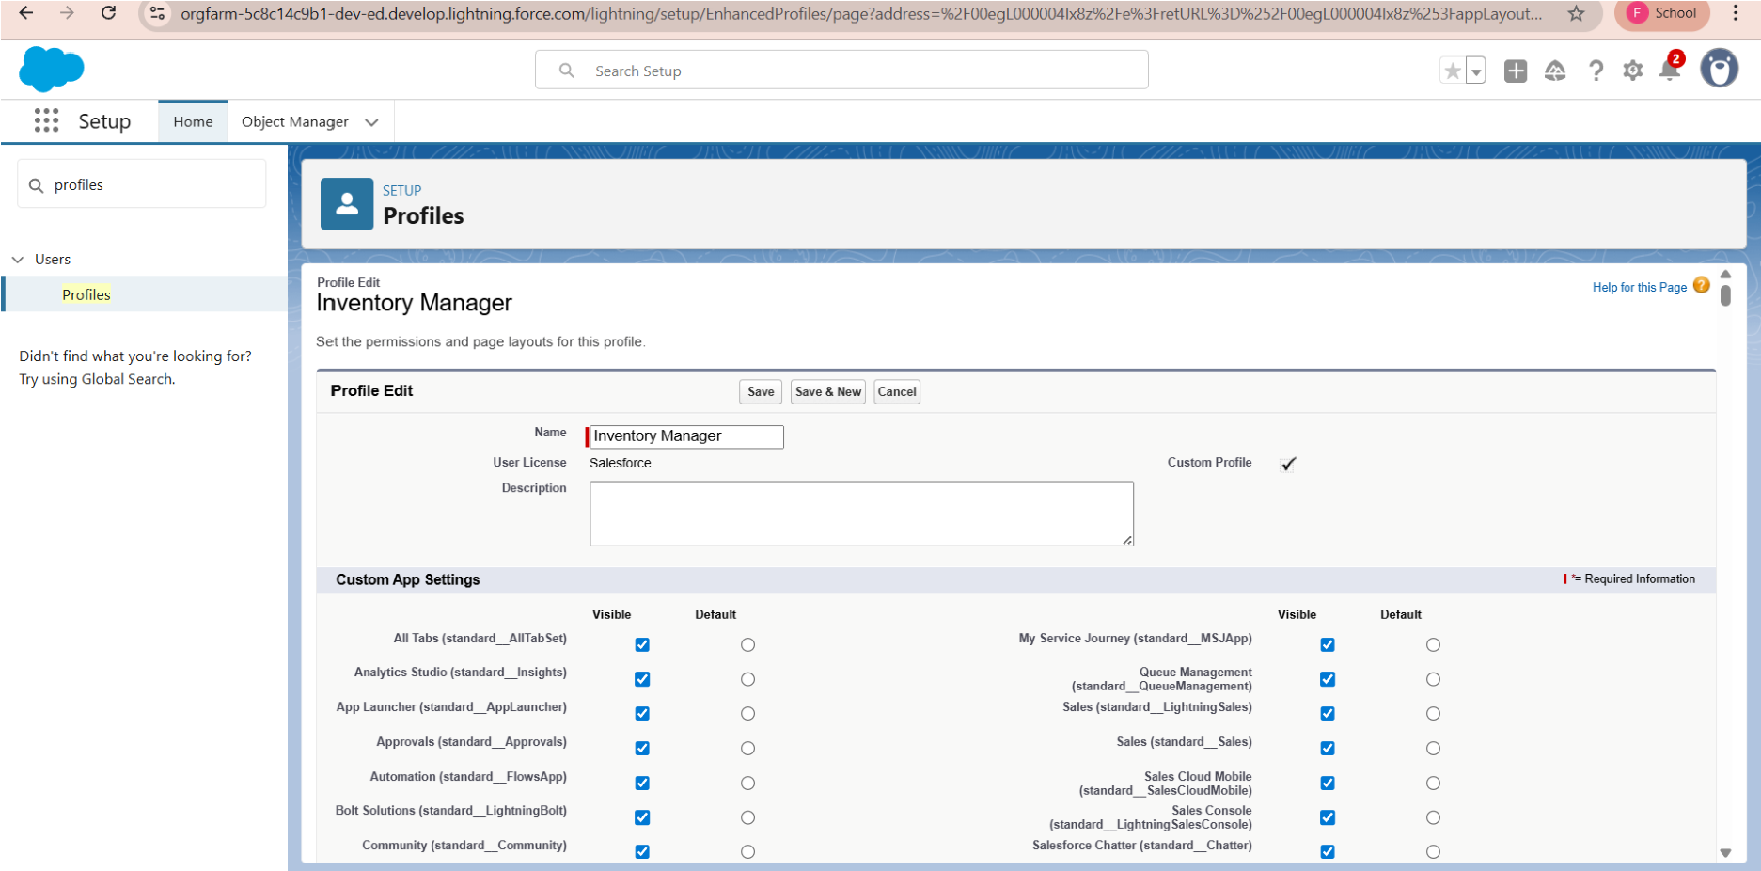

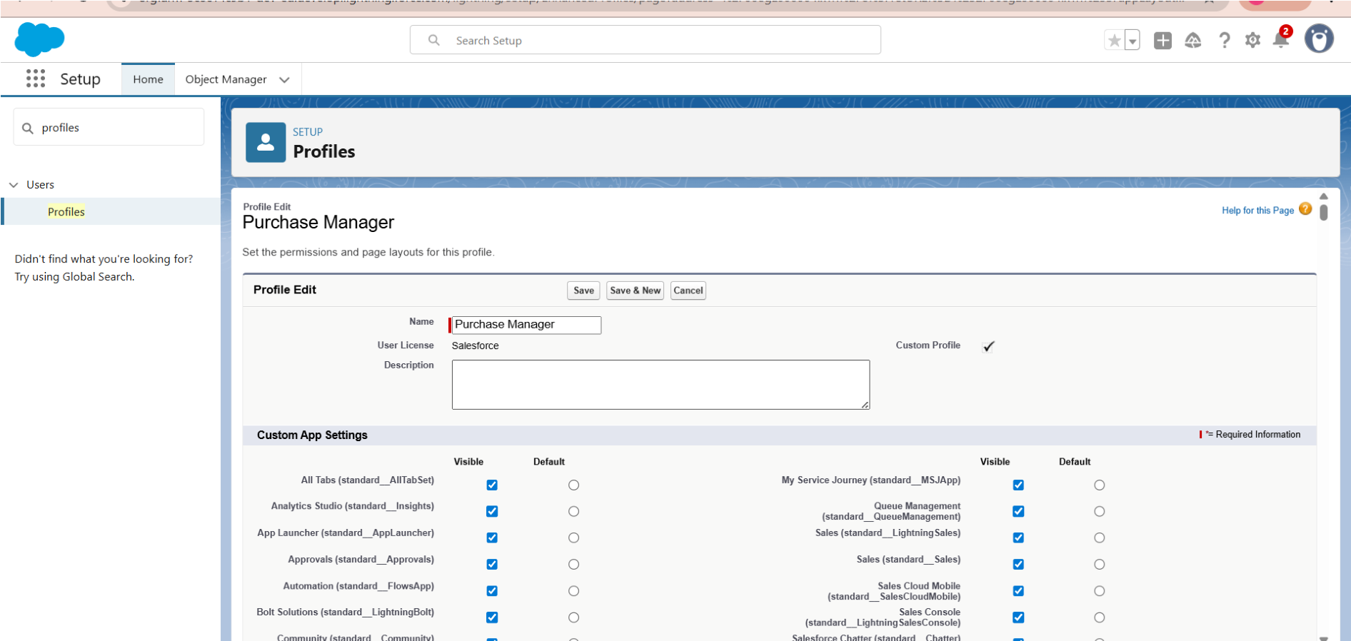

* To create a purchasing manager role under svp,sales and marketing role in roles And to create inventory manager role under svp sales and marketing role in roles tab

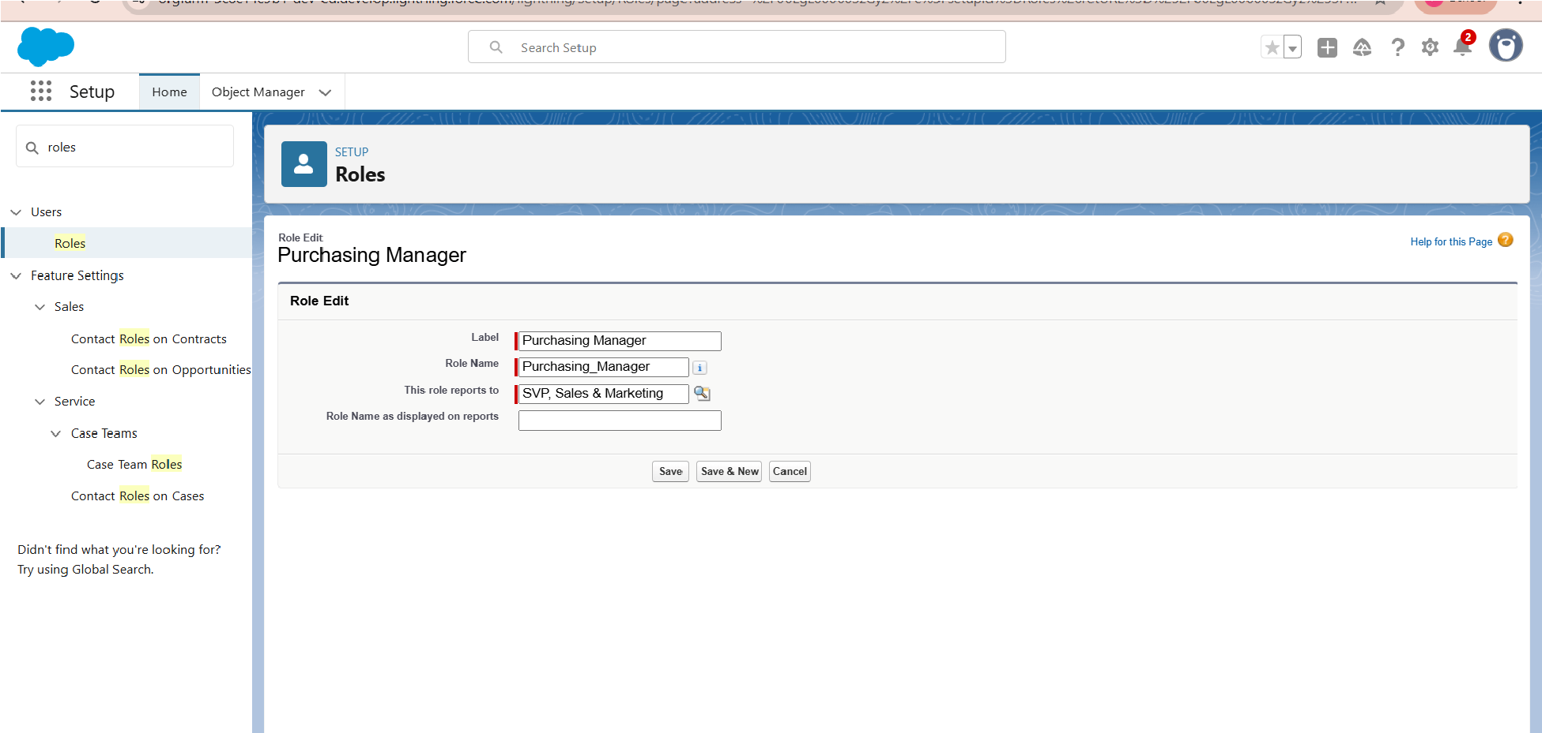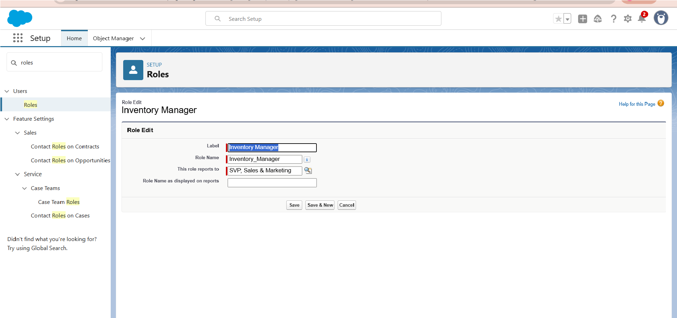

* Create a Permission set in name of

## Purchase manager create access

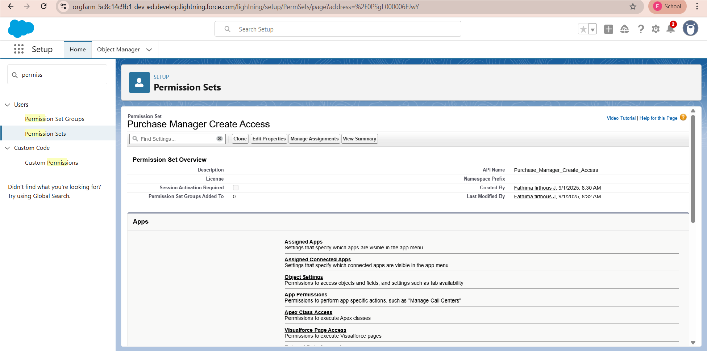

* To create a flow to update the Actual delivery date

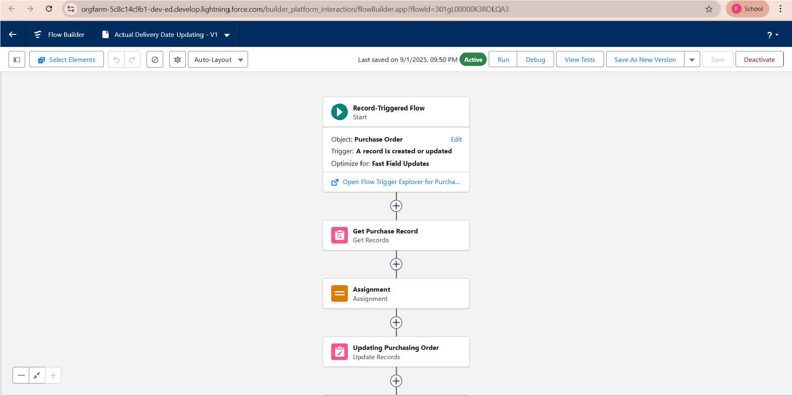

* To create a trigger to calculate total amount on order item in name of CalculateTotalAmountTrigger

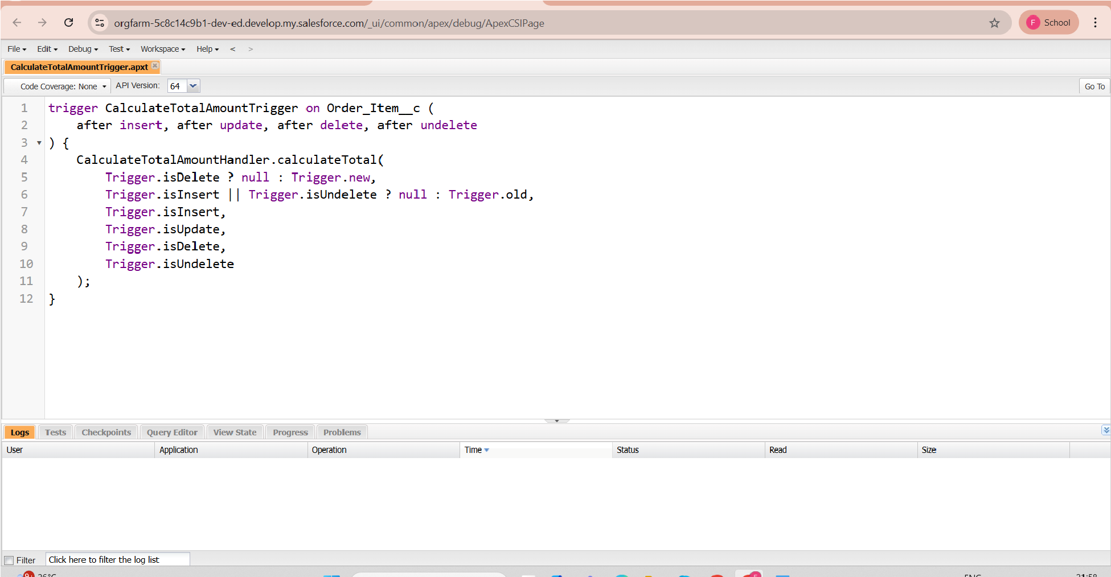

* Create a new class in developer console in name of CalculateTotalAmountHandler

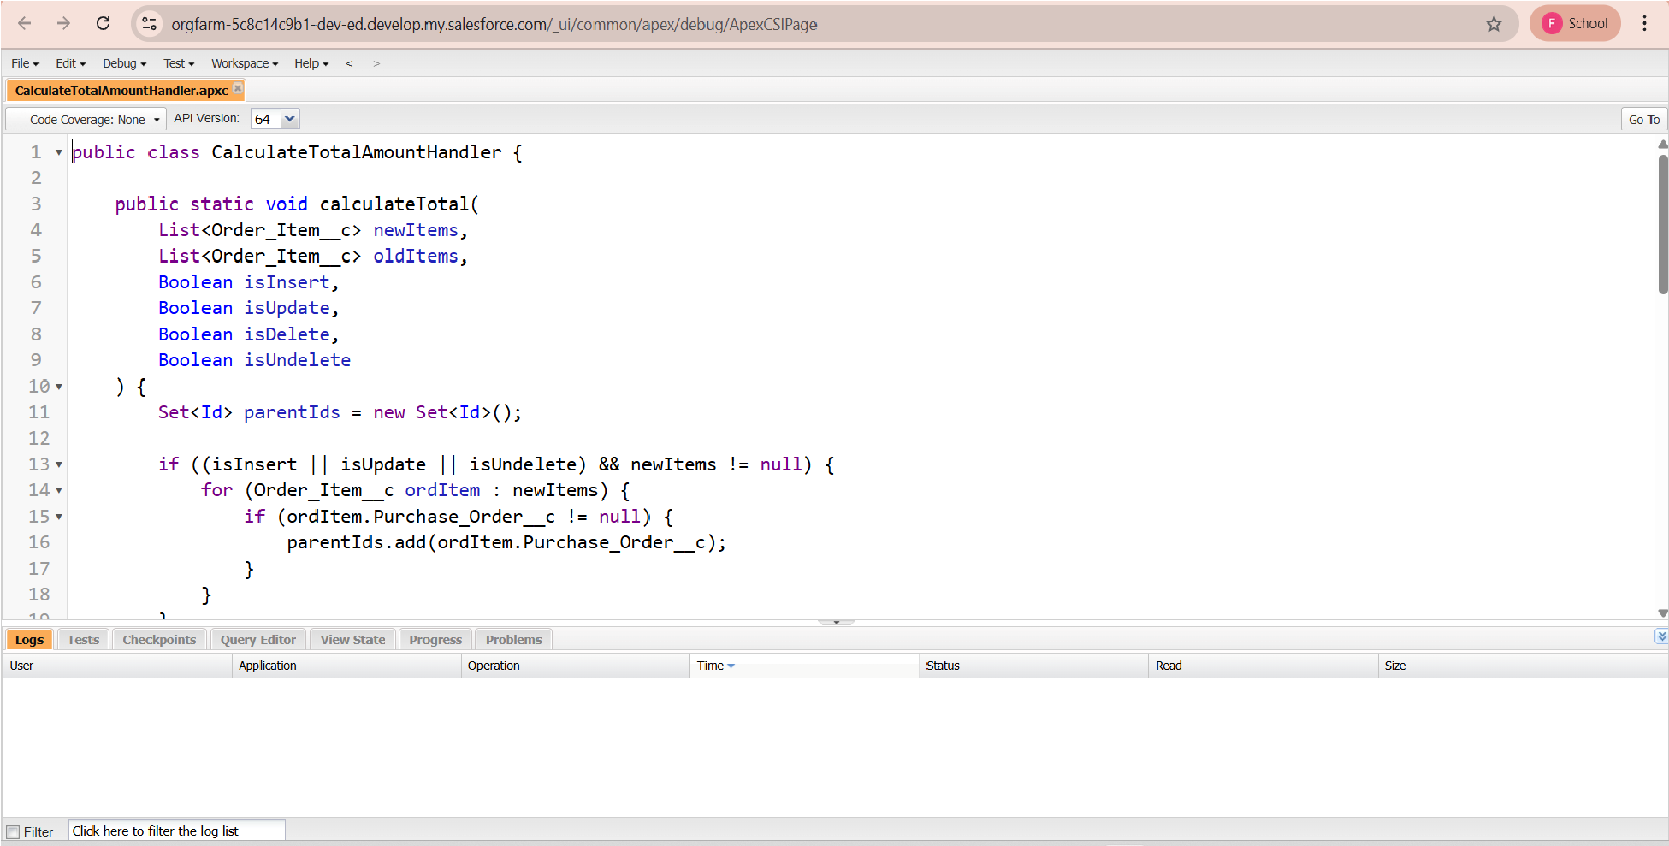

* Create a purchase order based on Suppliers in report

And also create complete purchase detail report

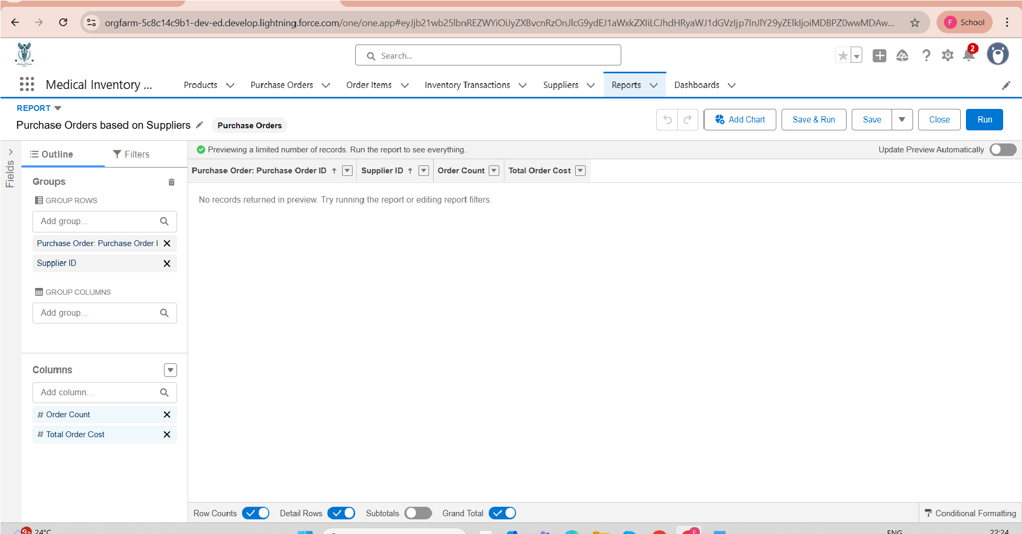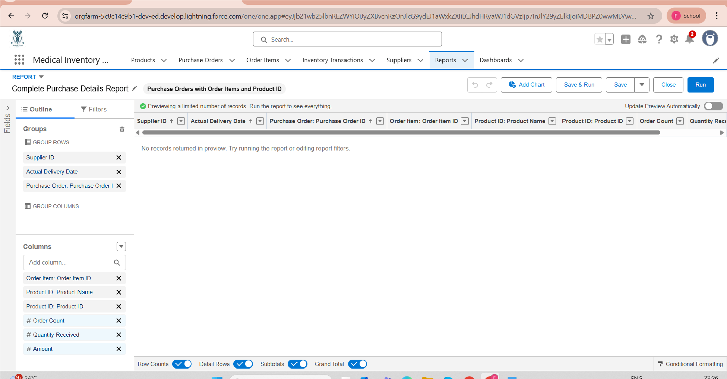

To create a new dashboard in the name of

Medical inventory dashboard

## And finally view the dashboard

